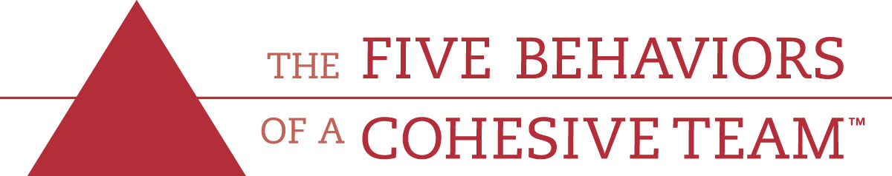
Team Survey
Using the scale below, indicate how each statement applies to your team. Briefly evaluate the statements without over-thinking your answers.
3=Usually 2=Sometimes 1=Rarely
- ___ Team members are passionate and unguarded in their discussion of issues.
- ___ Team members call out one another’s deficiencies or unproductive Behaviors.
- ___ Team members know what their peers are working on and how they contribute to the collective good of the team.
- ___ Team members quickly and genuinely apologize to one another when they say or do something inappropriate or possibly damaging to the team.
- ___ Team members willingly make sacrifices (such as budget, turf, headcount) in their departments or areas of expertise for the good of the team.
- ___ Team members openly admit their weaknesses and mistakes.
- ___ Team meetings are compelling and not boring.
- ___ Team members leave meetings confident that their peers are completely committed to the decisions that were agreed on, even if there was initial disagreement.
- ___ Morale is significantly affected by the failure to achieve team goals.
- ___ During team meetings, the most important – and difficult- issues are put on the table to be resolved.
- ___ Team members are deeply concerned about the prospect of letting down their peers.
- ___ Team members know about one another’s personal lives and are comfortable discussing them.
- ___ Team members end discussions with clear and specific resolutions and calls to action.
- ___ Team members challenge one another about their plans and approaches.
- ___ Team members are slow to seek credit for their own contributions, but quick to point out those of others.
Scoring- Combine your scores for the preceding statements as indicated below.

Dysfunction 1:
Absence of
Trust

#4___
#6___
#12___

Dysfunction 2:
Fear of
Conflict

#1___
#7___
#10___

Dysfunction 3:
Lack of
Commitment

#3___
#8___
#13___

Dysfunction 4:
Avoidance of
Accountability

#2___
#11___
14___

Dysfunction 5:
Inattention to
Results

#5___
#9___
15___

Total: ____
Total: ____
Total: ____
Total: ____
Total: ____

A score of 8 or 9 is a probable indication that dysfunction is not a problem for our team.
A score of 6 or 7 indicates that the dysfunction could be a problem.
A score of 3 to 5 is probably an indication that team dysfunction needs to be addressed.
Regardless of your scores, it is important to keep in mind that every team needs
constant work, because without it, even the best ones deviate toward dysfunction.
5 Dysfunctions Overview

Dysfunction#1: Absence of Trust-Occurs when team members are reluctant to be vulnerable with one another and unwilling to admit their mistakes, weaknesses or needs for help. Without a certain comfort level among team members, a foundation of trust is impossible.
Dysfunction#2: Fear of Conflict: The team is incapable of engaging in unfiltered, passionate debate about key issues, causing situations where team conflict can easily turn into veiled discussions and back channel comments. In a work setting where team member do not openly air their opinions, inferior decisions are the results.
Dysfunction#3: Lack of Commitment: Without conflict, it is difficult for team members to commit to decisions, creating an environment where ambiguity prevails. Lack of direction and commitment can make employees, particular start employees, disgruntled.
Dysfunction#4: Avoidance of Accountability: When teams don’t commit to a clear plan of action, even the most focused and driven individuals hesitate to call their peers on actions and behaviors that may seem counterproductive to the overall good of the team.
Dysfunction#5: Inattention to Results: Team members naturally tend to put their own needs (ego, career development, recognition, etc) ahead of the collective goals of the team when individuals aren’t held accountable. If a team has lost sight of the need for achievement, the business ultimately suffers.

